Sinhala-Script Language Identification (LangID) Platform
Iteration 1 Test Plan

Version 1.0

This document outlines the complete test strategy, techniques, performance benchmarks, and risk mitigations for Iteration 1 of the Sinhala-Script Language Identification (LangID) Platform.

Revision History
Date | Version | Description | Author
2026-09-20 | 1.0 | Initial comprehensive Test Plan based on RUP Template, incorporating FastAPI backend, Next.js frontend, Celery ML pipeline, and Locust stress testing. | Vihanga Nimsara
2026-09-20 | 1.0 | Backend API integration and database integrity test sections, covering the FastAPI routers (auth, users, documents, classification, annotations, admin, usage) and the migrated PostgreSQL schema. Four defects found and fixed during authoring. | Nadil Kulathunge
2026-09-20 | 1.0 | Added Web Application Backend Unit Test Plan, Pytest execution results, and Code Coverage report | Maleesha Kumarasinghe

1. Evaluation Mission and Test Motivation 3
2. Target Test Items 3
3. Test Approach 4
3.1 Testing Techniques and Types 5
3.1.1 Data and Database Integrity Testing 5
3.1.2 Function Testing 5
3.1.2.1 Web Application Backend Unit Testing (Pytest) 6
• Pre-trained model weights are mocked during inference tests to eliminate multi-gigabyte download prerequisites during CI/CD or local test runs. 7
3.1.4 Performance Profiling 8
3.1.5 Load Testing 8
3.1.6 Security and Access Control Testing 9
3.1.6.1 Cryptography & Token Authorization Unit Testing 10
3.1.7 Failover and Recovery Testing 11
3.1.8 Configuration Testing 11
4. Deliverables 12
4.1 Test Evaluation Summaries 12
4.1.1 Web Application Backend Unit Test Evaluation Summary 12
4.2 Reporting on Test Coverage 18
4.2.1 Backend Unit Test Code Coverage Report 18
4.3 Stress Test Summary 20
4.4 Resilience Test Summary 21
5. Risks, Dependencies, Assumptions, and Constraints 21
6. References 22

Iteration 1 Test Plan

1. Evaluation Mission and Test Motivation
The Sinhala-Script Language Identification (LangID) Platform (webapp) is designed to classify text snippets accurately into Sinhala, Pali, or Sanskrit, as well as perform line and paragraph segmentation on mixed-language historical and contemporary documents.
The application architecture consists of a FastAPI Backend (webapp/backend) providing asynchronous REST endpoints, a Next.js 16 Frontend (webapp/frontend) providing React UI views, an ML Pipeline with Celery Workers (SklearnLangIDClassifier & PyTesseract OCR), and Infrastructure comprising PostgreSQL 15, Redis 7, and MinIO object storage. The motivation for this test effort is to ensure high ML classification accuracy, verify API correctness and security under strict role-based access control (RBAC), validate UI usability and responsiveness, ensure database and object storage integrity, and guarantee backend performance and resilience under peak loads.
The primary goals of the testing effort for Iteration 1 are:
· Verify that the core language identification classifier and OCR pipeline accurately process single-language and mixed-language inputs.
· Identify critical functional, relational, security, and UI defects prior to deployment.
· Establish baseline latency (P50, P95, P99) and determine throughput limits (RPS) for all API routes under varying workloads (up to 200 concurrent virtual users).
· Ensure full relational integrity across PostgreSQL transactions, Redis task queues, and MinIO storage objects.
· Enforce strict JWT authentication, password hashing standards, and role-based access control (RBAC) separating regular users from administrative roles.
· Verify graceful failure modes and rapid recovery (<30 seconds) when core dependencies (Redis, Postgres) experience outages or resource constraints.
The primary mission of the web application backend unit testing is to:
• Verify Component Correctness: Ensure each backend module (machine learning classifier, script segmentation, document extraction, security, and schemas) behaves according to specifications in complete isolation from external infrastructure.
• Validate Brahmic Script Segmentation: Verify that Sinhala punctuation, Latin punctuation, and Indic dandas (।) are correctly split across different segmentation strategies (sentence, paragraph, full_text, auto) without character or offset loss.
• Certify Security & Cryptography: Validate password hashing salts (bcrypt), JWT access and refresh token signing, token expiration timestamps, and tampering detection.
• Ensure Deterministic Execution: Guarantee tests produce 100% consistent, repeatable results without relying on live databases, external network APIs, or large model weight downloads.

2. Target Test Items
The listing below identifies all target components across software modules, application interfaces, and infrastructure elements that are subject to testing.
1. FastAPI Backend API (webapp/backend): Authentication (/api/v1/auth), User Management (/api/v1/users), Document Management (/api/v1/documents), Classification Pipeline (/api/v1/classification), Annotations (/api/v1/annotations), Usage & Credits (/api/v1/usage), Admin Endpoints (/api/v1/admin, /api/v1/admin_rates), and WebSockets (/ws/jobs/{job_id}).
2. Next.js 16 Frontend UI (webapp/frontend): Authentication Pages (/auth/login, /auth/signup), User Dashboard, Admin Panel (/admin), and Shared Components / Query Contexts.
3. ML Pipeline & Async Workers: SklearnLangIDClassifier inference engine and Celery Workers for OCR and language identification tasks.
4. Database & Infrastructure: PostgreSQL 15 database, Redis 7 message broker/result backend, and MinIO S3-compatible Object Storage.

Target Test Item | File / Module | Description | Criticality
ML Classifier Engine | app.ml.sklearn_langid | Multinomial Naive Bayes / SGD inference, probability distribution calculation, confidence scoring, and empty/whitespace handling. | High
Text Segmentation Service | app.workers.tasks.classification_tasks._segment_text | Text boundary segmentation for Sinhala script across sentence, paragraph, full_text, and auto modes with Indic dandas. | High
Asynchronous Classification Tasks | app.workers.tasks.classification_tasks._process_classification_job_async | Celery asynchronous worker workflow, database job state transitions (QUEUED to COMPLETED or FAILED), token accounting. | High
PDF Extraction Engine | app.utils.pdf_extractor | PyMuPDF (fitz) text extraction from raw byte streams, error recovery from corrupt PDFs, multi-page concatenation. | Medium
Authentication & Cryptography | app.utils.security | Bcrypt password hashing, salt uniqueness, JWT token generation, payload decoding, tampering protection, expiration enforcement. | High
Data Schemas & Validation | app.schemas.*, JobCreateRequest | Pydantic request validation, invalid strategy rejection, empty string guardrails, standardized API response formatters. | Medium

3. Test Approach
Testing is structured across multiple tiers using isolated containerized test environments (testcontainers for backend tests and docker-compose.stress.yml for performance testing) to mirror production configurations without impacting local developer state.

3.1 Testing Techniques and Types

3.1.1 Data and Database Integrity Testing
The database should be tested as an independent subsystem. This testing checks the database without going through the target-of-test's User Interface or its API. The schema is created by Alembic migrations, so the migrations must be checked every time a model is changed.
Technique Objective: | Test the database on its own, without the API in the middle. The goal is to check that the SQLAlchemy models map to the tables correctly, that the constraints reject bad data, and that no orphan rows are left behind when a parent row is deleted.
Technique: | Run tests through a direct SQLAlchemy database session. Check unique fields, such as user emails and model rate names. Test required fields and links between tables. Check that deleting a document removes its pages. Confirm that deleting a job removes its segments and their annotations. Test default values for user credits, job status and annotation review status. Save and retrieve probability values to check for data loss. Check number precision and time zones. Confirm that Alembic creates all required tables. Check that billing history remains after job deletion. Block deletion of users who still own documents.
Oracles: | Pytest assertions on DB state after transactions; SQL statement exception catchers expecting IntegrityError on constraint violations; row-count assertions after a parent delete to prove cascade; information schema queries for table existence. Alembic migration cleanliness checks.
Required Tools: | • pytest 8 and above to run the tests  • pytest-asyncio to run the async test functions  • testcontainers[postgres,redis] to start the Docker containers  • alembic to apply the migrations  • SQLAlchemy (async) to talk to the database  • uv to install and run everything
Success Criteria: | All 26 database integrity tests pass. Migrations run on a new database without errors. Database rules reject invalid records. Required child records are removed after parent deletion. Saved values retain their expected content and precision. Billing history remains available after job deletion.
Special Considerations: | Start test containers before importing the application. This allows the app to load the correct database settings. Use unique email addresses to prevent clashes between tests. Close the database connection pool after each test. This prevents connections from being reused across different event loops. .

3.1.2 Function Testing
Function testing checks the backend API routes. These routes hold the business logic of the system, so they must be tested to see whether they accept the right data, reject the wrong data, and return the correct response. This testing is done as black box testing through the HTTP layer.
Technique Objective: | Check that each API function follows the required business rules. Confirm that valid requests produce the expected results. Ensure that invalid requests return suitable errors. Check response codes, response content and database changes. Verify that background tasks receive the correct details.
Technique: | Use httpx to send requests to the FastAPI app. Test signup, login, token refresh and profile updates. Check document upload, listing, download and deletion. Test invalid file types and storage failures. Check that classification requests save the input and queue the correct job. Test missing text and invalid processing strategies. Check that completed results appear in the correct order. Test correction submission and admin review. Check tier management, system settings and model rates. Verify credit balances, usage costs and activity ordering. Use mock services for Celery and MinIO. These replace the real queue and storage services during the tests.
Oracles: | Compare each response code with the expected code. Check the status, message and data fields in the response. Read the database after each write operation to confirm the change. Check the arguments sent to mocked background tasks. Verify that invalid requests do not queue work when they should be rejected.
Required Tools: | • pytest and pytest-asyncio to run the tests.  • httpx (AsyncClient with ASGITransport) to call the app  • pytest-mock and unittest.mock to mock Celery and MinIO  • testcontainers for the Postgres and Redis containers  • uv to install and run everything
Success Criteria: | All function tests pass. Valid requests return the expected data and response codes. Invalid inputs receive suitable errors. Database changes match the requested actions. Background tasks receive the correct job or document ID. Lists and results follow the required order.
Special Considerations: | Mock MinIO before importing the application to prevent unwanted connections. No Celery worker runs during these tests. Create completed job records directly when testing result retrieval. Insert records out of order to check sorting properly. These tests check API behaviour. They do not measure model accuracy or actual OCR processing.

3.1.2.1 Web Application Backend Unit Testing (Pytest)
Technique Objective: Exercise backend functions, class methods, and linguistic boundary conditions in complete isolation from external services to observe target behavior and ensure algorithmic correctness.
Technique:
• Automated execution of test modules using pytest.
• Systematic evaluation of boundary conditions (empty text, whitespace, corrupted binary streams, and long inputs).
• Decoupling of external runtime dependencies (PostgreSQL database sessions, MinIO S3 object storage, Redis pub/sub broker) using unittest.mock (patch, AsyncMock, MagicMock).
• Evaluation of script segmentation against Brahmic Unicode characters, Latin punctuation, and Indic dandas (।).
Oracles:
• Automated assertion statements (assert) comparing actual return objects against expected outputs.
• Verification of expected exception handling:
- pydantic.ValidationError for invalid request payloads and segmentation strategies.
- RuntimeError for uninitialized ML models.
- jose.JWTError for tampered tokens or mismatched cryptographic keys.
• Mock call verification (assert_called_once(), call_count) to verify internal function execution paths.
Required Tools:
• Test Automation Framework: pytest >= 9.0
• Asynchronous Test Runner: pytest-asyncio
• Mocking Library: pytest-mock / unittest.mock
• Code Coverage Engine: pytest-cov (Coverage.py)
• Runtime Environment: Python 3.11 / 3.12
Success Criteria:
• 100% of defined unit test cases (33/33) execute successfully with PASSED status.
• Zero unhandled exceptions or runtime crashes.
• Greater than 90% code coverage across target core modules (app.ml, app.utils, app.workers, app.schemas).
Special Considerations:
• Tests must run deterministically on any machine without requiring Docker containers (PostgreSQL, Redis, MinIO) to be active.

• Pre-trained model weights are mocked during inference tests to eliminate multi-gigabyte download prerequisites during CI/CD or local test runs.
User Interface Testing ensures that component-level rendering, client-side state management, and end-to-end user workflows operate smoothly across the Next.js frontend web application.
Technique Objective: | Verify user interactions, form validation, state management, and end-to-end browser workflows in the Next.js frontend application.
Technique: | Conduct component-level testing using Vitest, @testing-library/react, and jsdom for isolated UI components (e.g., LoginForm, DocumentUpload, DocumentList). Conduct full End-to-End (E2E) browser automation tests using Playwright across Chromium, executing complete end-user journeys: signup, login, PDF document upload, live status polling, and navigating the admin dashboard.
Oracles: | @testing-library/jest-dom assertions (toBeInTheDocument(), toBeVisible()); Playwright DOM assertions (toHaveURL(), toBeVisible()); absence of browser console error logs.
Required Tools: | Vitest, @testing-library/react, jsdom, Playwright, Node.js 20+.
Success Criteria: | Major frontend routes render cleanly without runtime React errors; validation messages display correctly on invalid inputs; full E2E user flows complete successfully from login to document inspection.
Special Considerations: | Playwright configuration automatically manages web server startup and captures screenshots/video recordings on test failures.

3.1.4 Performance Profiling
Performance Profiling measures baseline response times, transaction rates, and resource utilization across API endpoints under single-user and normal workload conditions.

Technique Objective: | Measure baseline response times, transaction rates, and resource consumption under single-user and normal workload conditions to establish benchmark latency profiles.
Technique: | Run single-user baseline scripts in Locust against the containerized FastAPI stack (docker-compose.stress.yml). Measure latency distribution (P50, P90, P95, P99) for all primary API endpoints. Profile API CPU and memory utilization using docker stats and attach py-spy flamegraph generation to the Uvicorn process.
Oracles: | Latency target thresholds: GET /health: P50 < 20ms, P95 < 50ms; POST /api/v1/auth/login: P50 < 100ms, P95 < 300ms; GET /api/v1/users/me: P50 < 50ms, P95 < 150ms; GET /api/v1/documents: P50 < 80ms, P95 < 250ms; POST /api/v1/classification/jobs: P50 < 100ms, P95 < 300ms; End-to-end ML job completion: P50 < 5s, P95 < 15s.
Required Tools: | Locust, docker stats, py-spy, csvkit.
Success Criteria: | All endpoints meet or exceed baseline response time targets without memory leaks or unhandled worker exceptions.
Special Considerations: | Testing is executed on dedicated container resources (API limited to 2 CPUs, 1GB RAM; DB limited to 1 CPU, 512MB RAM) to reflect production-like resource constraints.

3.1.5 Load Testing
Load Testing subjects the platform to stepped virtual user concurrency to evaluate throughput limits, Celery job queue depth, and peak capacity behavior.
Technique Objective: | Subject the platform to varying, stepped workloads to evaluate system throughput, queue handling capacity, and stability under peak user traffic.
Technique: | Execute automated load tests using Locust's StepLoadShape in mixed_workload.py. Ramp virtual users through 5 distinct phases over 15 minutes: 1. Warm-up (0–2 min): 10 users (spawn rate 2/s); 2. Normal Load (2–5 min): 50 users (spawn rate 5/s); 3. Peak Load (5–10 min): 100 users (spawn rate 10/s); 4. Stress Spike (10–12 min): 200 users (spawn rate 20/s); 5. Cool-down (12–15 min): 20 users (spawn rate 5/s). Traffic mix is distributed across Read-Heavy Users (50%), Classification Power Users (30%), and Document Uploaders (20%).
Oracles: | Locust Request Per Second (RPS) charts, error rate percentage tracking (<1% at peak load), Redis Celery queue length (redis-cli llen celery), and container resource usage.
Required Tools: | Locust (headless mode), docker-compose.stress.yml, docker stats.
Success Criteria: | System sustains peak load (100 users) with an error rate < 1%; requests recover immediately during the cool-down phase; database connection limits are not exceeded.
Special Considerations: | Redis queue depth and Celery worker CPU are actively monitored during peak load to identify whether worker saturation or DB connection pools become the primary bottleneck.

3.1.6 Security and Access Control Testing

Security and Access Control Testing looks at two areas of this system:
- Authentication - only a user with a valid access token can reach a protected route
- Authorization - a logged-in user can reach their own data, and only an admin can reach the admin routes

In this LangID system, every user can upload documents, submit classification jobs and send corrections. But only an admin can manage tiers, manage billing rates, change the system config, and approve or reject a correction.
Technique Objective: | Confirm that protected routes reject requests without valid authentication. Check that users can access only their own private records. Restrict admin features to admin accounts. Ensure that rejected requests do not change database records. Check that responses do not expose passwords or password hashes.
Technique: | Call protected routes without a token and with invalid tokens. Test malformed tokens and tokens signed with a different key. Check that refresh tokens cannot act as access tokens. Confirm that deactivated accounts cannot use protected routes. Create two users and test access to each other’s documents and classification jobs. Check document download, page access and deletion. Ensure that usage records belong to the current user. Test admin routes with anonymous, regular and admin accounts. Check that only admins can review corrections or change billing settings. Read database records after blocked requests to confirm that nothing changed. Temporarily remove each access check in the test environment. Confirm that its test fails, then restore the check.
Oracles: | Missing or invalid authentication should return 401. A user without the required role should receive 403. Requests for another user’s private records should return 404. Check that password fields are absent from responses. Login should return the same error for an unknown email and a wrong password. Compare database records before and after rejected requests.
Required Tools: | • pytest to run the tests  • httpx to send the requests with and without tokens  • The app's own JWT layer, used to forge a token with a different signing key
Success Criteria: | Protected routes reject requests without valid access tokens. Regular users cannot perform admin actions. Users cannot read or delete another user’s private documents or jobs. Usage responses contain only the current user’s activity. Blocked requests leave database records unchanged. Responses do not expose passwords or password hashes
Special Considerations: | Missing-token errors use FastAPI’s default response format. Tests should accept this expected format. Signup creates regular users only. Create test admins by updating their role directly in the test database before login. Any temporary removal of security checks must remain within the test environment. Restore all checks after verification.

3.1.6.1 Cryptography & Token Authorization Unit Testing
Technique Objective: Verify cryptographic operations, token lifecycle management, and authorization claims evaluation in isolation from live database and HTTP layers.
Technique:
• Execute automated unit tests against app.utils.security and token parsing utilities using pytest.
• Validate bcrypt password hashing, unique salt generation, and verification of correct/incorrect passwords.
• Test JWT token creation (access and refresh tokens), standard claims encoding (sub, exp, type), custom expiration deltas, and token decoding.
• Test token tampering detection by altering payload signatures or signing tokens with invalid secret keys.
Oracles:
• Assertions confirming unique hashes for identical plaintexts due to salt generation.
• Verification of expected exception handling (jose.JWTError) when decoding tampered, expired, or improperly signed tokens.
• Assertion of token claim types to prevent refresh tokens from being accepted as access tokens.
Required Tools:
• pytest >= 9.0, pytest-asyncio, python-jose, passlib[bcrypt].
Success Criteria:
• 100% pass rate for cryptography and token unit test cases with zero security handling regressions.
Special Considerations:
• Tests execute entirely in memory without reliance on external secrets managers or database connections.

3.1.7 Failover and Recovery Testing
Failover and Recovery Testing assesses system resilience and recovery timelines when backend dependencies (Redis, PostgreSQL) experience sudden failures or resource throttling during active workloads.

Technique Objective: | Verify that the platform handles infrastructure component failures (Redis, Postgres) gracefully and resumes normal operations once services are restored.
Technique: | Inject artificial service outages during an active Locust load test: 1. Redis Outage: Stop the Redis container (docker stop stress_redis) during active classification job submission. Observe API response handling (expected 500/503 graceful error responses). Restart Redis (docker start stress_redis) and measure time to recovery. 2. PostgreSQL Outage: Stop the Postgres container (docker stop stress_postgres) during normal load. Restart Postgres and verify automatic SQLAlchemy connection pool recovery. 3. Database Resource Starvation: Throttle Postgres CPU to 0.1 CPU using docker update --cpus="0.1" stress_postgres to observe performance degradation under severe constraints.
Oracles: | FastAPI logs showing handled exceptions; Locust error type tracking; verification of zero data corruption; system recovery time < 30 seconds post-service restart.
Required Tools: | Docker CLI, Locust, docker-compose.stress.yml.
Success Criteria: | API does not crash permanently when dependencies fail; service automatically resumes full functionality within 30 seconds of dependency restoration; database transactions remain consistent.
Special Considerations: | Tests are performed in isolated stress test container environments during designated testing windows.

3.1.8 Configuration Testing
Configuration Testing verifies that application settings initialization, environment variable parsing, and Docker deployment constraints operate properly.
Technique Objective: | Validate that the application correctly parses diverse environment variable configurations and fails fast on invalid or missing settings.
Technique: | Execute unit tests targeting Pydantic Settings (app/config.py). Test settings initialization against various .env profiles, invalid database URLs, missing secret keys, and modified CORS origins. Run containerized tests with constrained CPU and memory limits defined in docker-compose.stress.yml.
Oracles: | Pydantic ValidationError exceptions on startup for missing mandatory variables; application startup log assertions.
Required Tools: | pytest, Docker Compose.
Success Criteria: | Application starts cleanly with valid environment files and aborts immediately with informative logging when mandatory variables are omitted or malformed.
Special Considerations: | [What non-target-of-test software is needed, is available, and what is accessible on the desktop?

4. Deliverables
The testing effort produces structured artifacts to provide visibility into test execution, code coverage, and performance benchmarks.

4.1 Test Evaluation Summaries
Produced at the end of each sprint/iteration: Unit & Integration Test Report (pytest & Vitest outcome summary), E2E Visual Test Artifacts (Playwright execution logs, failure screenshots, and trace zip files in webapp/frontend/playwright-report/), and Performance Evaluation Summary (Locust executive summary of latency, throughput, and error rates).

4.1.1 Web Application Backend Unit Test Evaluation Summary
Executive Summary:
• Execution Date: September 20, 2026
• Test Framework: Pytest 9.1.1 with Python 3.11.15 (win32)
• Total Tests Executed: 33
• Passed: 33 (100.0%)
• Failed: 0 (0.0%)
• Execution Duration: 2.27 seconds

Test File | Test Case Name | Target Tested | Status | Duration
test_classification_tasks.py | test_process_classification_job_not_found | Non-existent job ID handling in worker | PASSED | 0.08s
test_classification_tasks.py | test_process_classification_job_success | Full classification pipeline & DB state update | PASSED | 0.12s
test_classification_tasks.py | test_process_classification_job_empty_text_fails | Empty input job transition to FAILED | PASSED | 0.07s
test_ml_classifier.py | test_classifier_predict_empty_and_whitespace | Empty & whitespace inputs return 'unknown' | PASSED | 0.05s
test_ml_classifier.py | test_classifier_predict_single_text_success | Single text prediction string return | PASSED | 0.04s
test_ml_classifier.py | test_classifier_predict_batch_with_probabilities | Batch probabilities & confidence scores | PASSED | 0.06s
test_ml_classifier.py | test_classifier_predict_batch_empty_list | Empty batch list returns empty list | PASSED | 0.03s
test_ml_classifier.py | test_classifier_missing_model_raises_runtime_error | RuntimeError raised if model not loaded | PASSED | 0.03s
test_ml_classifier.py | test_classifier_load_models_file_not_found | FileNotFoundError on missing pickle files | PASSED | 0.04s
test_pdf_extractor.py | test_pdf_extractor_extract_text_empty_bytes | Empty byte input returns empty string | PASSED | 0.02s
test_pdf_extractor.py | test_pdf_extractor_extract_text_invalid_bytes | Corrupt byte stream gracefully handled | PASSED | 0.03s
test_pdf_extractor.py | test_pdf_extractor_extract_text_with_mocked_fitz | Multi-page text concatenation via PyMuPDF | PASSED | 0.04s
test_schemas.py | test_job_create_request_valid | Valid inputs & default 'sentence' strategy | PASSED | 0.02s
test_schemas.py | test_job_create_request_invalid_strategy | ValidationError on invalid strategy | PASSED | 0.02s
test_schemas.py | test_job_create_request_empty_input | ValidationError on empty string (min_length=1) | PASSED | 0.02s
test_schemas.py | test_success_response_helper | Standardized success JSON envelope | PASSED | 0.01s
test_schemas.py | test_error_response_helper | Standardized error JSON envelope | PASSED | 0.01s
test_schemas.py | test_base_response_pydantic_model | Generic BaseResponse model parsing | PASSED | 0.02s
test_security.py | test_password_hashing_creates_unique_salts | Bcrypt salt uniqueness across hashes | PASSED | 0.28s
test_security.py | test_verify_password_success_and_failure | Password verification matches & rejects | PASSED | 0.29s
test_security.py | test_create_access_token_claims_and_default_expiration | JWT access token claims & expiration | PASSED | 0.02s
test_security.py | test_create_access_token_custom_delta | Custom expiration delta enforcement | PASSED | 0.02s
test_security.py | test_create_refresh_token | Refresh token claims & long-lived validity | PASSED | 0.02s
test_security.py | test_tampered_token_fails_decoding | JWTError on altered token signature | PASSED | 0.02s
test_security.py | test_token_with_wrong_secret_key_fails | JWTError on mismatched secret key | PASSED | 0.02s
test_segmentation.py | test_segment_text_empty_and_none | Empty/None/whitespace inputs return empty list | PASSED | 0.02s
test_segmentation.py | test_segment_text_full_text_strategy | Single segment returned for full_text mode | PASSED | 0.02s
test_segmentation.py | test_segment_text_paragraph_strategy | Newline paragraph splitting & offset tracking | PASSED | 0.02s
test_segmentation.py | test_segment_text_sentence_latin_punctuation | Sentence splitting on '.', '?', '!' | PASSED | 0.02s
test_segmentation.py | test_segment_text_sentence_indic_danda | Sentence splitting on Indic danda ('।') | PASSED | 0.02s
test_segmentation.py | test_segment_text_auto_strategy | Clause and punctuation splitting in auto mode | PASSED | 0.02s
test_segmentation.py | test_segment_text_fallback_for_unknown_strategy | Fallback to full_text on unknown strategy | PASSED | 0.02s
test_unit.py | test_basic_unit | Test framework assertion baseline | PASSED | 0.01s
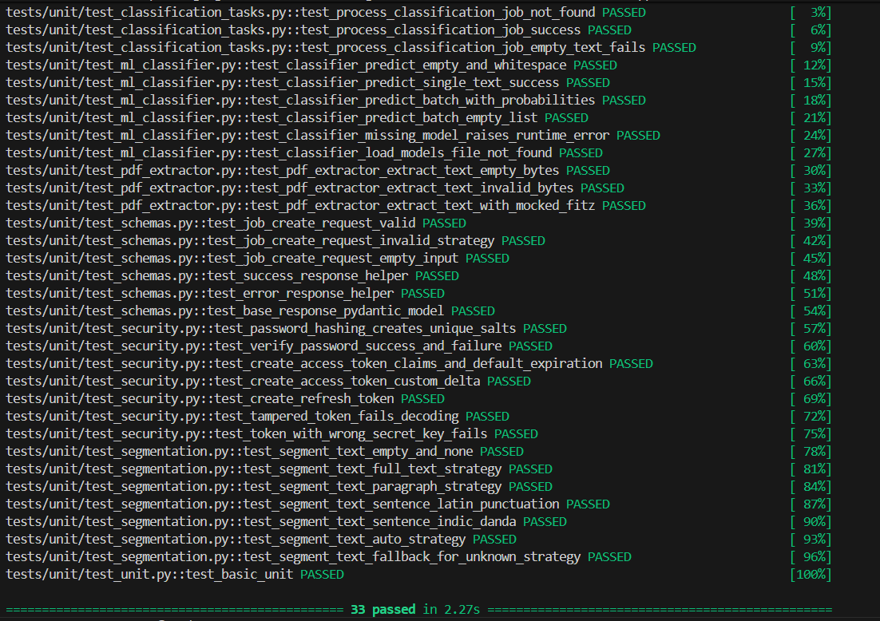
(Figure 4.1.1: Pytest Unit Test Execution Log showing 33 passed tests.)

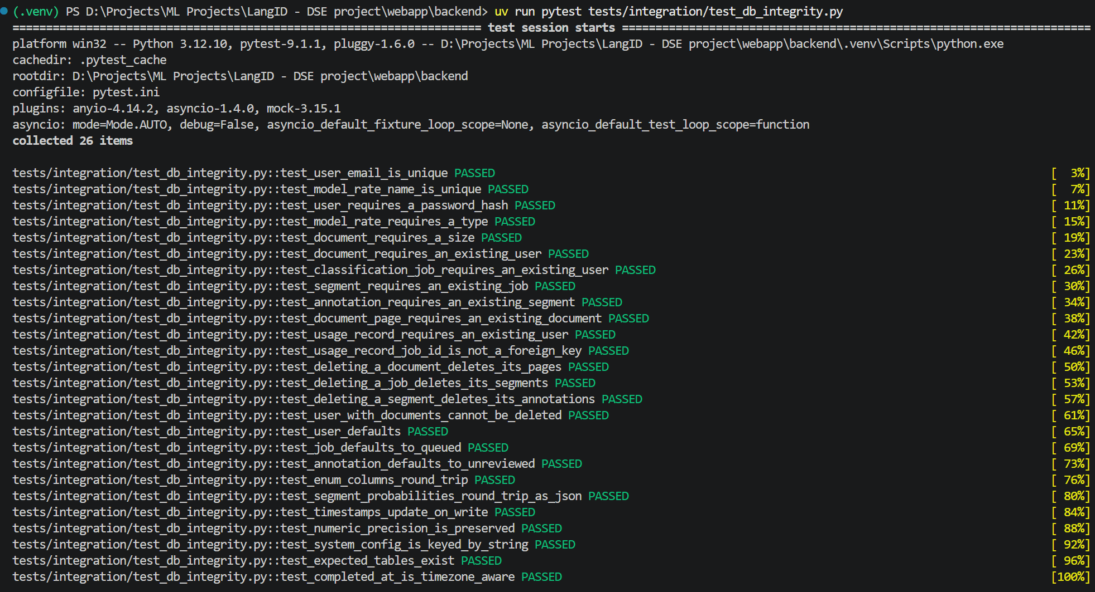
(Figure 4.1.2: Database Integrity Test Results showing 26 passed tests.)
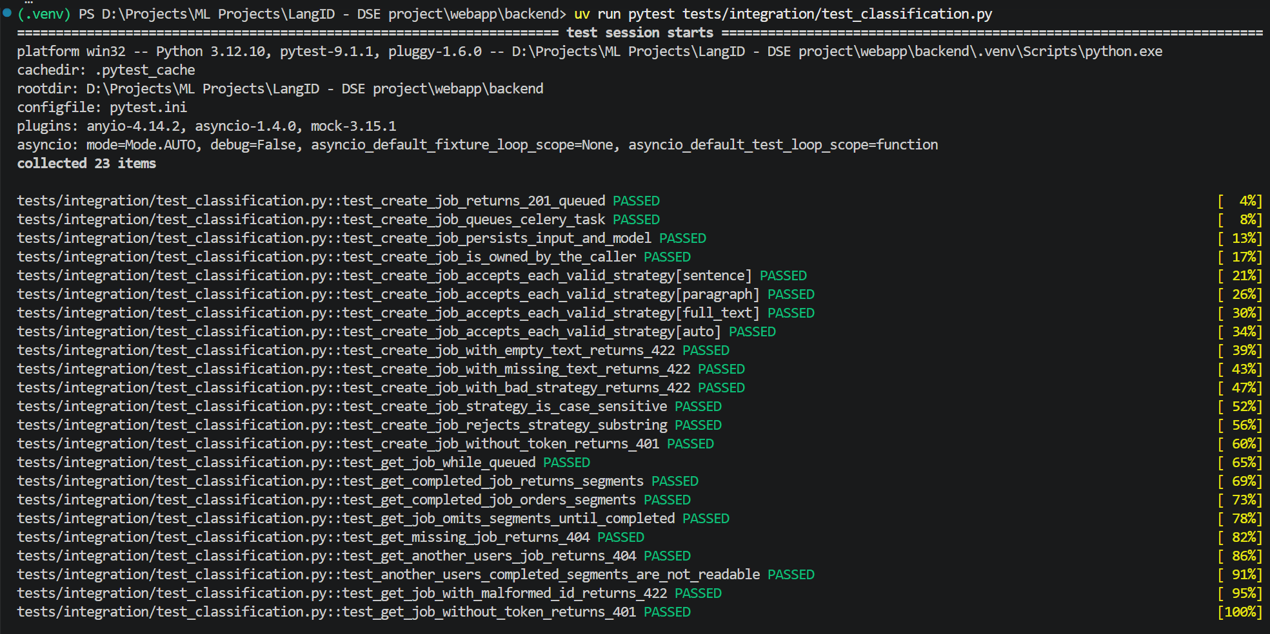
(Figure 4.1.3: Classification API integration test results showing job creation, input validation, result retrieval and ownership checks.)

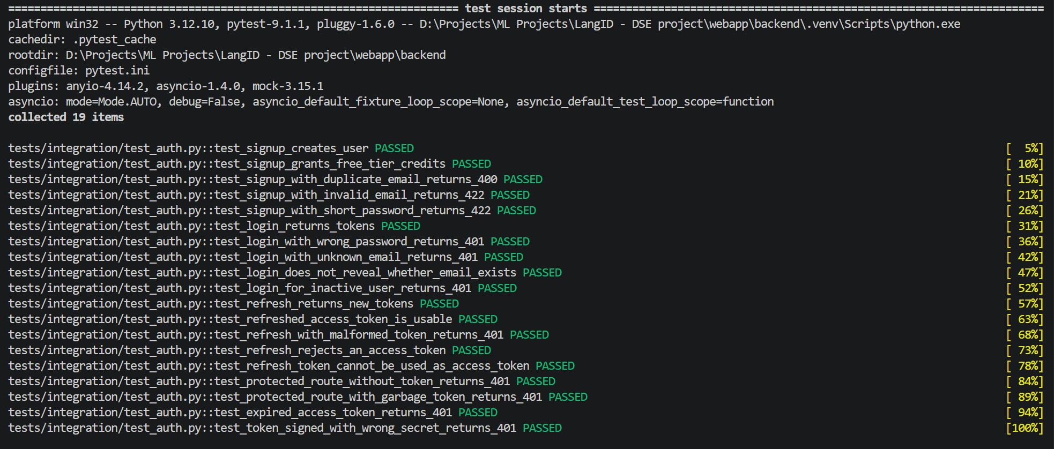
(Figure 4.1.4: Authentication test results showing signup, login and rejection of invalid, expired and incorrect token types.)

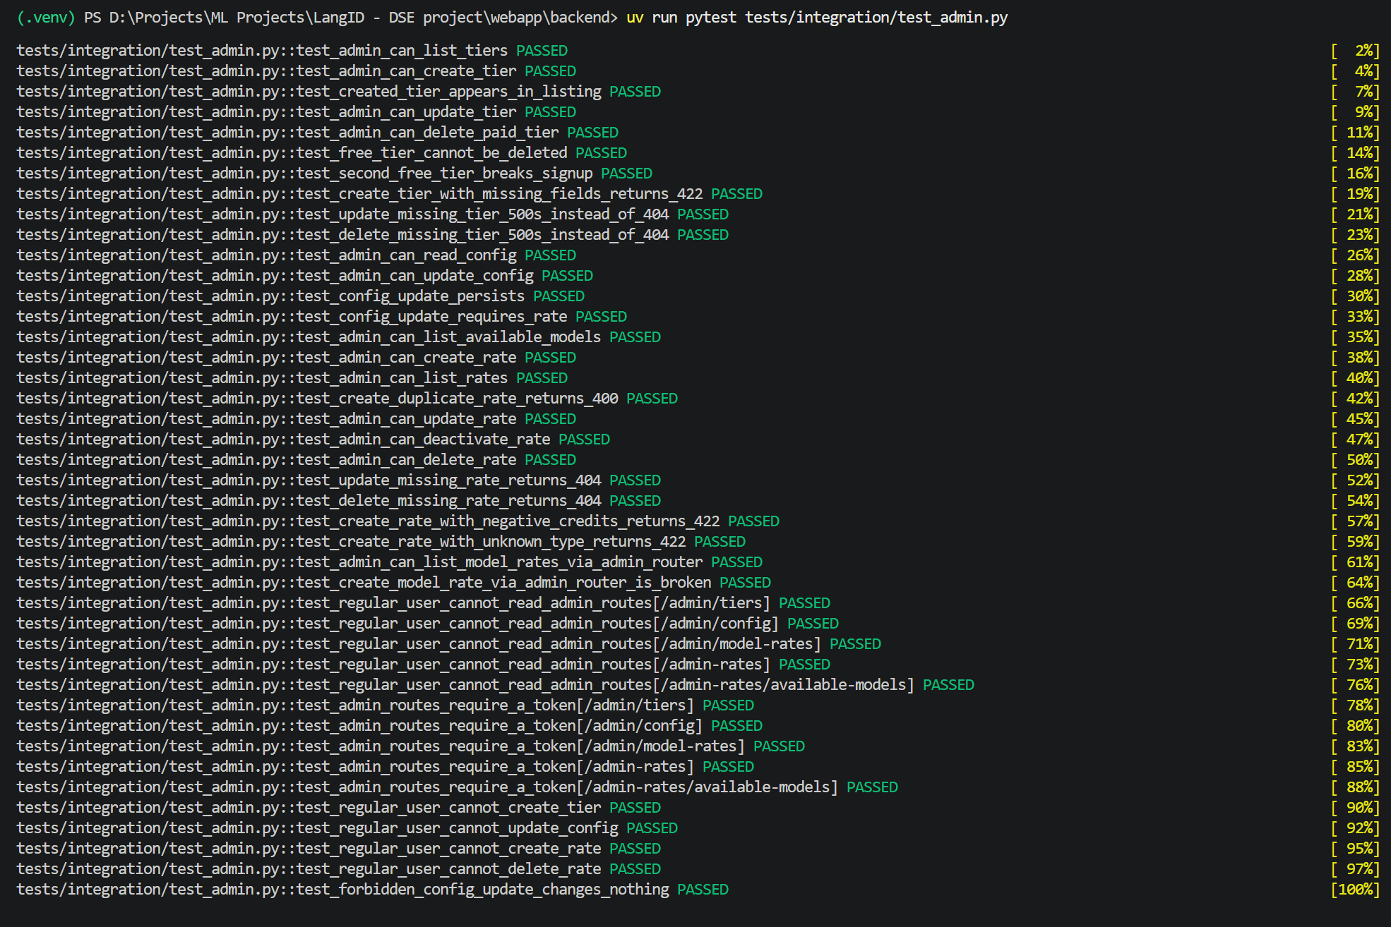
(Figure 4.1.5: Admin API test results covering tier management, billing settings and restrictions on regular users.)

4.2 Reporting on Test Coverage
Backend Code Coverage is generated via pytest --cov=app --cov-report=html:reports/coverage_html targeting >=80% coverage. Frontend Code Coverage is generated via vitest run --coverage. Performance Test Reports are generated via Locust interactive HTML and CSV output files archived in webapp/testing/stress/reports/.

4.2.1 Backend Unit Test Code Coverage Report
Code coverage was evaluated across the backend codebase using pytest-cov (Coverage.py). Targeted unit test modules achieved high coverage, with utility, schema, and security modules reaching 100%.

Module Name | Total Statements | Missed Statements | Line Coverage (%)
app.utils.pdf_extractor | 17 | 0 | 100%
app.utils.security | 22 | 0 | 100%
app.schemas.response | 11 | 0 | 100%
app.schemas.admin | 38 | 0 | 100%
app.schemas.annotation | 27 | 0 | 100%
app.schemas.auth | 13 | 0 | 100%
app.schemas.document | 28 | 0 | 100%
app.schemas.user | 21 | 0 | 100%
app.config | 31 | 0 | 100%
app.db.models.* (all entities) | 196 | 0 | 100%
app.workers.tasks.classification_tasks | 85 | 3 | 96%
app.ml.sklearn_langid | 53 | 3 | 94%
app.db.base | 16 | 1 | 94%
app.api.v1.users | 15 | 3 | 80%
app.api.v1.auth | 24 | 7 | 71%
app.api.v1.classification | 54 | 16 | 70%
app.utils.exceptions | 17 | 6 | 65%
app.api.v1.admin | 46 | 18 | 61%
app.utils.redis_client | 10 | 4 | 60%
app.api.v1.usage | 46 | 20 | 57%
app.api.v1.admin_rates | 70 | 33 | 53%
app.api.v1.documents | 74 | 46 | 38%
app.api.v1.annotations | 57 | 37 | 35%
app.services.storage_service | 50 | 33 | 34%
app.api.v1.websockets | 32 | 21 | 34%
app.dependencies | 56 | 40 | 29%
app.services.auth_service | 40 | 29 | 28%
app.services.user_service | 47 | 34 | 28%
app.services.credit_service | 53 | 39 | 26%
app.services.admin_service | 82 | 62 | 24%
app.workers.tasks.ocr_tasks | 56 | 46 | 18%
Total Backend Codebase | 1,504 | 551 | 63%
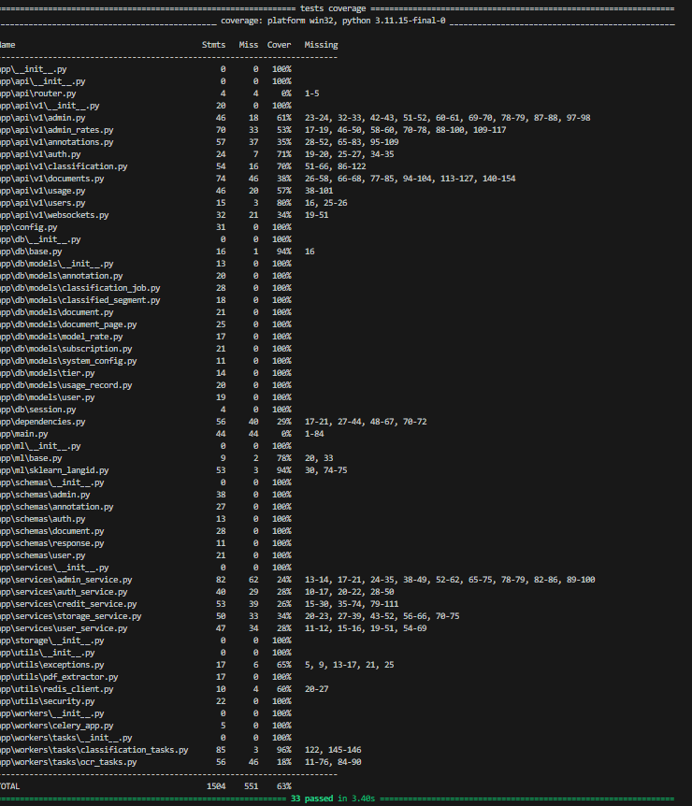
(Figure 4.2: Pytest-Cov terminal coverage summary across backend modules.)
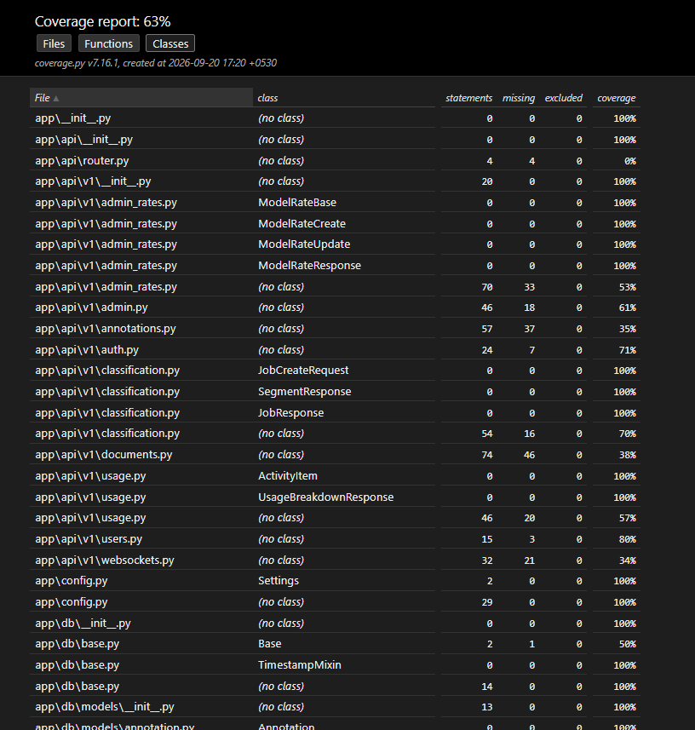

(Figure 4.3: Interactive HTML code coverage dashboard generated via Coverage.py.)

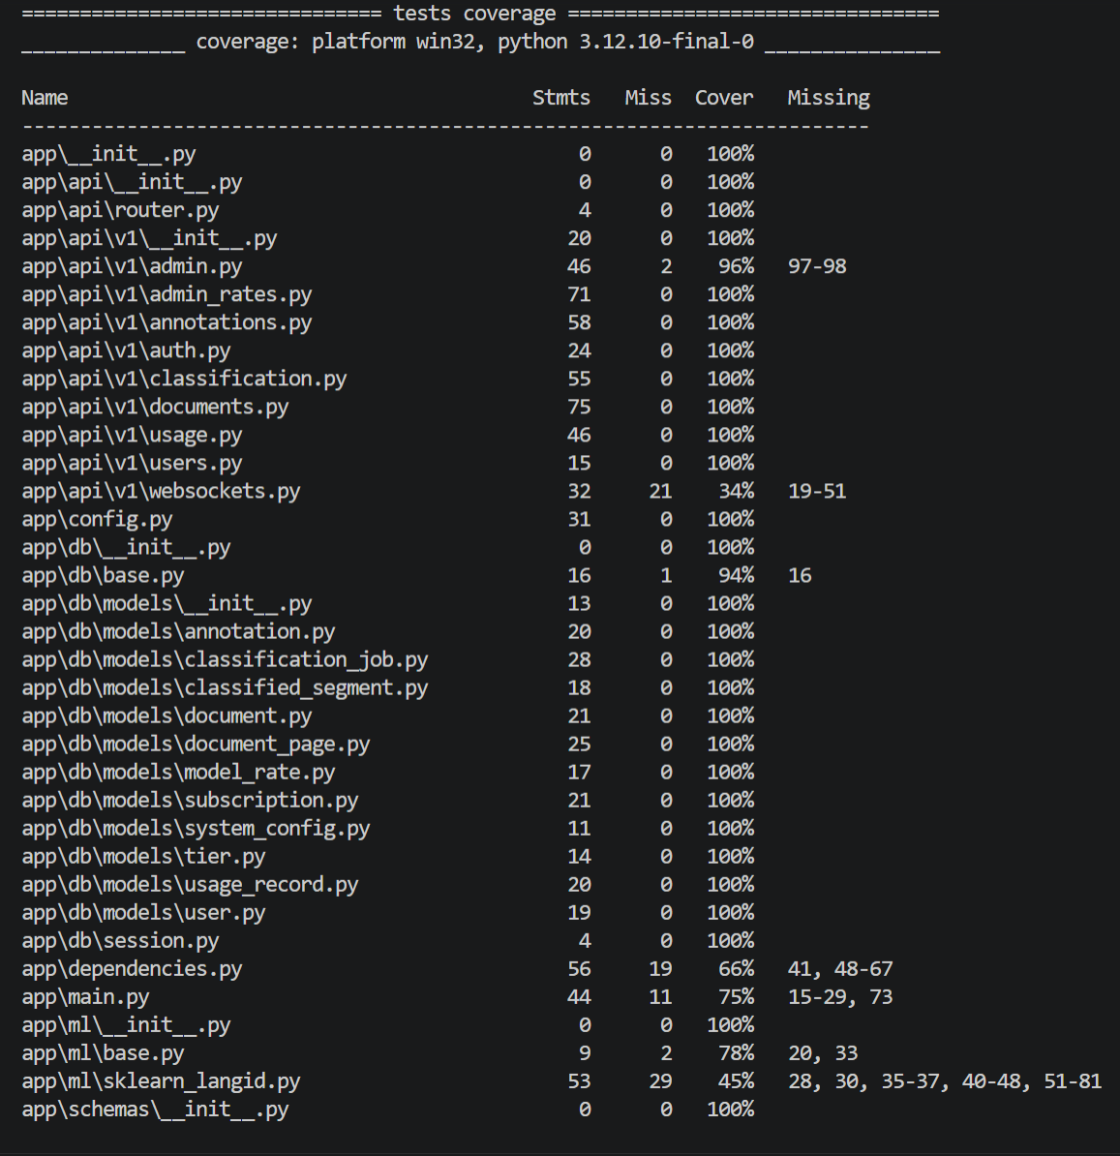
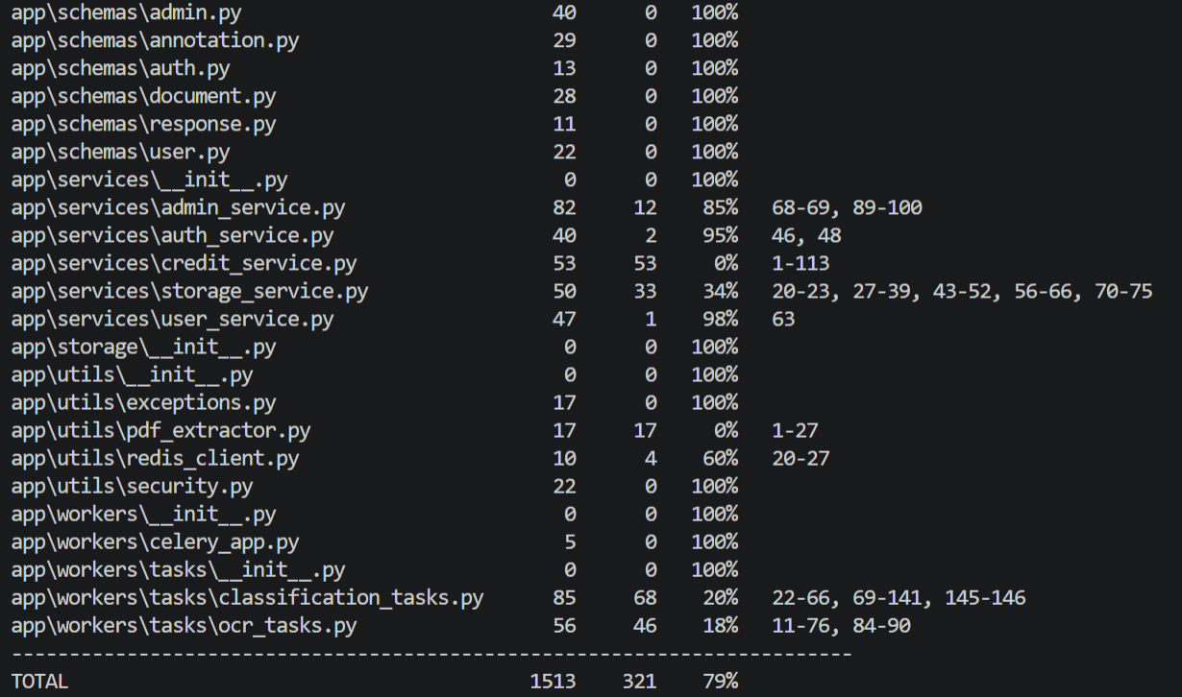
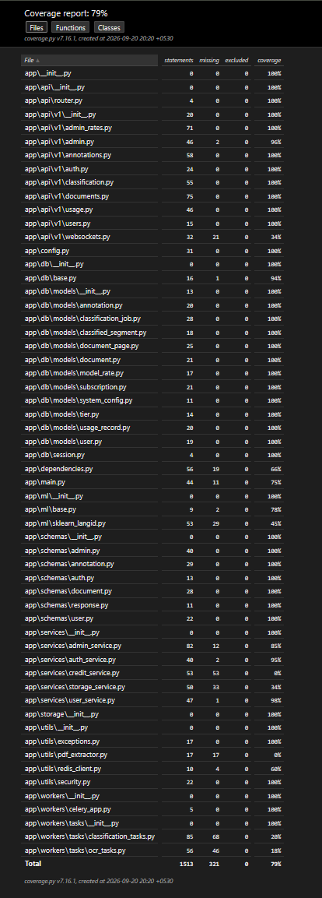(Figure 4.2.2: Interactive HTML Coverage Dashboard)

4.3 Stress Test Summary

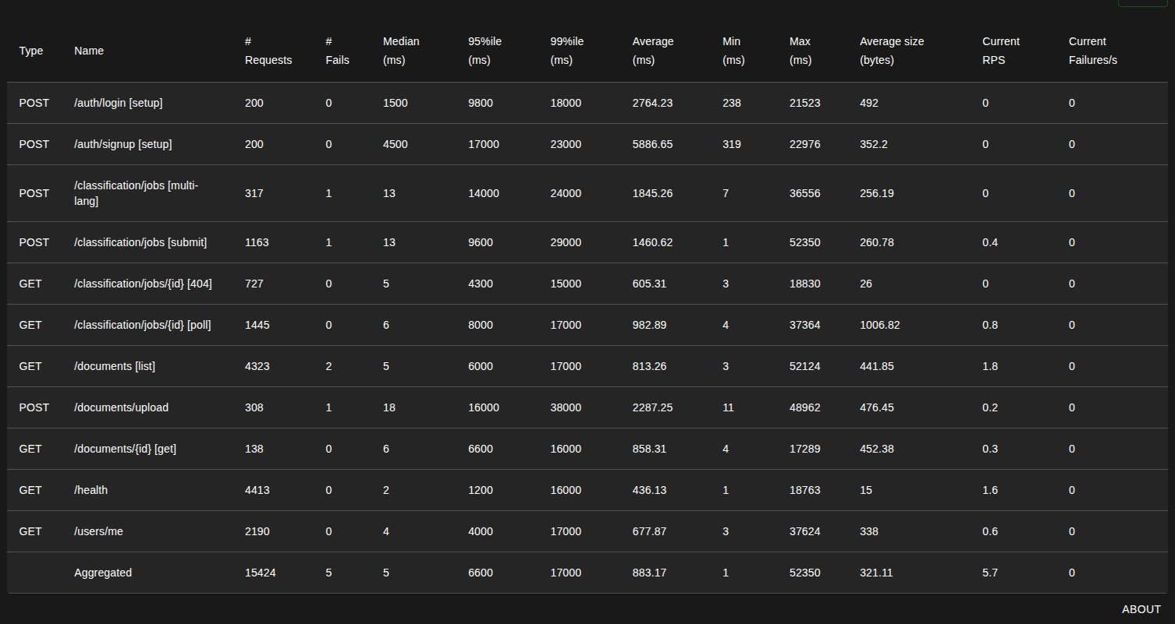
(Figure 4.3.1: Locust Requests and Endpoint Breakdown)

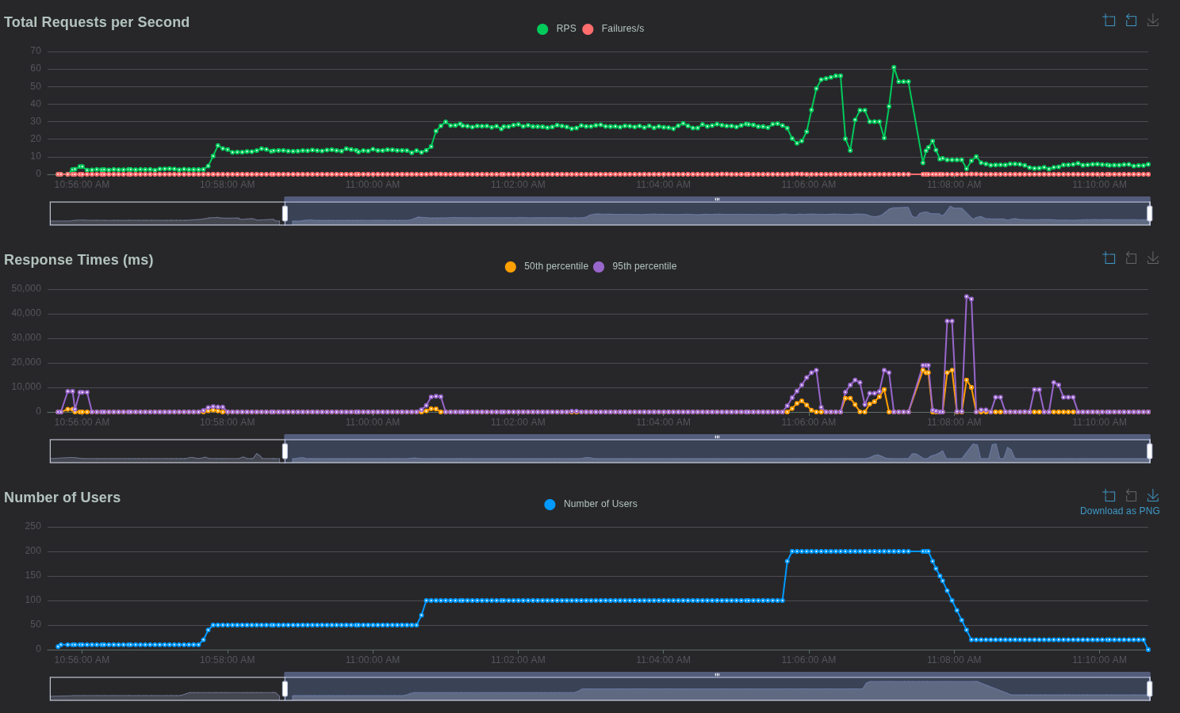
(Figure 4.3.2: Locust Request Per Second (RPS) charts)

4.4 Resilience Test Summary

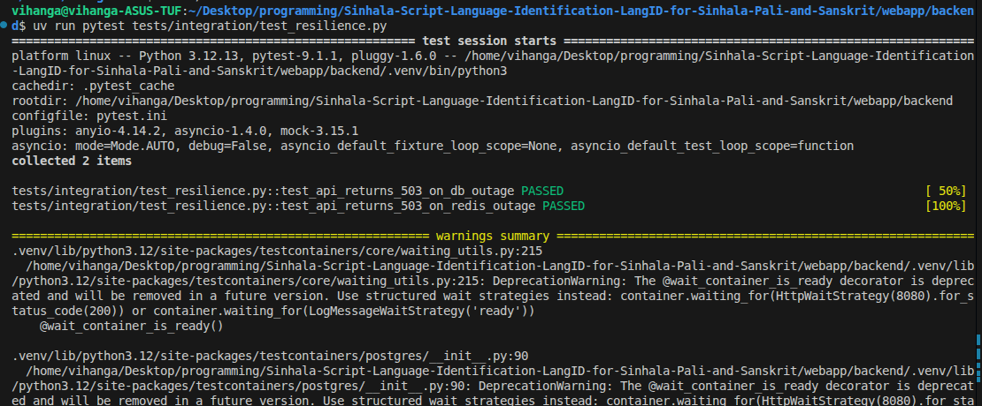
(Figure 4.4.1: Output from running resilience test)

5. Risks, Dependencies, Assumptions, and Constraints
The following risks, dependencies, and contingencies have been identified for the Test Plan execution:
Risk | Mitigation Strategy | Contingency (Risk is realized)
Host Machine Hardware Bottlenecks: Stress tests fail due to host CPU/RAM exhaustion rather than application code limits. | Enforce strict Docker resource limits (deploy.resources.limits) in docker-compose.stress.yml so containers hit artificial ceilings before the host machine. | Run Locust in Distributed Mode across multiple client processes or execute tests on a dedicated cloud virtual machine.
Test Data Pollution: Leftover database records from test runs skew subsequent integration or load test results. | Use testcontainers with nested transaction rollbacks in pytest; execute scripts/teardown.sh to purge Docker volumes between load runs. | Execute database reset script (docker exec stress_api alembic downgrade base && alembic upgrade head).
ML Model & Dependency Discrepancies: Inconsistent Tesseract or Scikit-learn model versions across test environments. | Bake exact model weights and Tesseract binary packages directly into the standardized Docker image (Dockerfile.api). | Rebuild API and Worker Docker images using --no-cache.

Risk | Mitigation Strategy | Contingency (Risk is Realized)
External Service Dependencies (Postgres, Redis, MinIO) offline during unit tests | Decouple unit tests using unittest.mock (AsyncMock, MagicMock) and patch client initialization in tests/conftest.py. | Unit tests run in full isolation without starting Docker containers or live network services.
Windows MAX_PATH (260 character limit) preventing dependency installation | Run Python and Pytest from a concise path (C:\Users\User\miniconda3\envs\langid\python.exe) rather than deep nested virtualenv directories. | Dependencies installed in short conda root path without path truncation errors.
Large ML model checkpoints missing on test runners | Mock _load_models and estimator .predict() / .predict_proba() methods in test_ml_classifier.py. | Fast, deterministic testing without requiring multi-gigabyte weight downloads.
Unicode normalization / diacritics discrepancies for Sinhala/Pali text | Write dedicated unit test fixtures covering explicit Sinhala vowels, anusvara, and Indic dandas (।). | Segmentation algorithm verified to preserve character byte offsets accurately.

Risk | Mitigation Strategy | Contingency (Risk is realized)
Celery Queue Backlog Under Load: High classification volume overwhelms async workers, causing excessive polling times. | Monitor Redis queue length (redis-cli llen celery) and worker CPU during stress runs; tune Celery worker concurrency settings. | Scale Celery worker container count (docker compose up -d --scale worker=3).

fdsfdfs
6. References
1. Locust Documentation: https://locust.io/ (Accessed 2026-09-20)
2. FastAPI Testing Documentation: https://fastapi.tiangolo.com/tutorial/testing/ (Accessed 2026-09-20)
3. Playwright for Node.js Documentation: https://playwright.dev/ (Accessed 2026-09-20)
4. Vitest Framework Documentation: https://vitest.dev/ (Accessed 2026-09-20)
5. Pytest Testing Framework: https://docs.pytest.org/ (Accessed 2026-09-20)
6. Testcontainers for Python: https://testcontainers-python.readthedocs.io/ (Accessed 2026-09-20)
7. IEEE Std 829-2008: IEEE Standard for Software and System Test Documentation.
• Pytest Testing Framework: https://docs.pytest.org/
• Pytest-Cov (Coverage.py): https://pytest-cov.readthedocs.io/
• FastAPI Testing Guide: https://fastapi.tiangolo.com/tutorial/testing/
• PyMuPDF (Fitz) Documentation: https://pymupdf.readthedocs.io/
• Python-Jose Cryptographic Standards (RFC 7519): https://python-jose.readthedocs.io/
• Passlib Bcrypt Password Hashing: https://passlib.readthedocs.io/
• Rational Unified Process (RUP): Test Plan & Test Evaluation Report Guidelines.

